Started at 22-08-2017 03:45pm

Declaration and Access Modifiers

We will discuss the following topics   
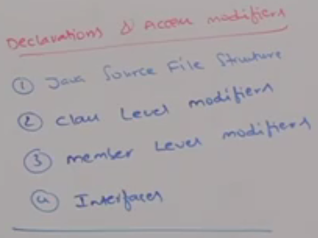

Starttttttttttttttttttttttt ☺ ☺

1. A java program can contain any number of classes but at most one class (meaning o or 1) can be declared as public.
2. If there is a public class, then name of the java file and name of the public class must match otherwise we’ll get compile time error.
3. **Case 01**: If there is no public class, then we can give any name to java file (there is no restriction).  
   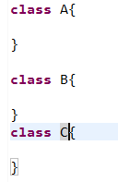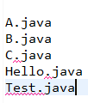

As there is no public class so we can give any name to java file.

1. **Case 02**: If class B is public, then the name of the java file should be **B.java** otherwise we will get compile time error saying   
   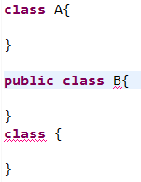



1. **Case 03**: If class B and C are declared as public and the name of the program is B.java, then we will get compile time error saying   
   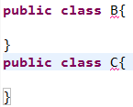
2. **Case04:** Durga.java

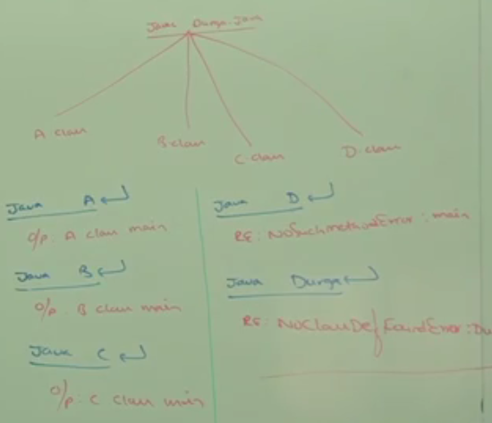

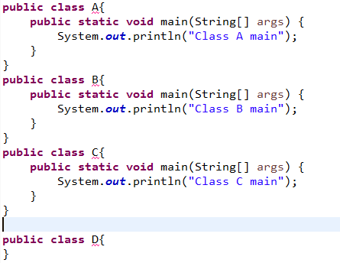

**Conclusion**:

* Whenever we are compiling a java program, for every class present in the program a separate .class file is generated.
* **\*\*\***We compile a java source file but we run a java class file.
* Whenever we are executing a java class file, the corresponding main method will be executed. If the class doesn’t contain main() then we will get run time exception saying **NoSuchMethodError:main**
* If the corresponding .class file is not available, then we will run time exception saying **NoClassDefFoundError**
* It’s not recommended to declare multiple classes in a single source file. It’s highly recommended to declare only one class per source file. Name of the source file (program), we have to keep same as class name. The main advantage of this approach is
  + readability improvement
  + maintainability improvement

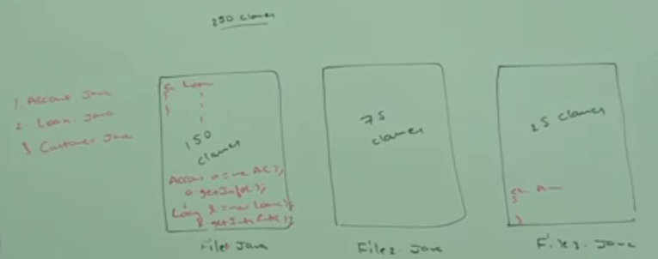

Not Recommended ☺

1. **d**

import statement

1. 
2. 
3. **Solution**: fully-qualified class name  
   
4. The problem with using fully-qualified class name every time is
   1. it increases the length of the code
   2. it reduces the readability.
5. **Solution**: import statement.
6. Whenever we write import statement, it’s not required to use fully-qualified class name every time. We can use short name directly. Such as   
   